State of Hawaii
Department of the Attorney General

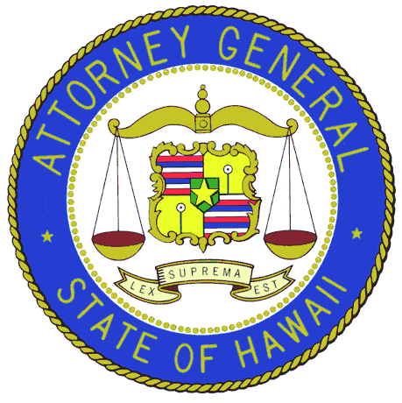

Report on
Litigation Deposits Trust Fund Transactions
And
Collections Made on Behalf of Other Departments and Agencies

For Fiscal Year 2004 - 2005

Submitted to
The Twenty-Third State Legislature
Regular Session of 2006

Table of Contents

Overview of the Litigation Deposits Trust Fund 1

Details of Revenues and Expenditures 3

Summary of Collections 5
Overview of the
Litigation Deposits Trust Fund

The Litigation Deposits Trust Fund, appropriation number T-909-N, was established pursuant to Act 178, Session Laws of Hawaii 2002, to account for moneys received through any civil action in which the State is a party where the settlement amount is $100,000 or higher. Pursuant to section 28-16, Hawaii Revised Statutes, the trust fund is administered by the Department of the Attorney General, which must annually report to the Legislature (1) the transactions, by subsidiary account, that take place in the fund for each fiscal year, and (2) a summary of the collections made in any amount on behalf of other departments and agencies specifying the appropriate number of transactions and amount collected for each department and agency.

During Fiscal Year (FY) 2004-2005, the following significant transactions occurred in the trust fund:

- The Department received in FY 2004-2005 the final payment of $75,000 of a settlement in the amount of $250,000 entered into with a vendor in its role in administering the Felix Demonstration project from October 1, 1996 through June 30, 1997. The moneys from this settlement are to be used to further the Felix investigation, to include cost for investigators and any other expert/consultants needed for current Felix-related activities. As of June 30, 2005, the trust fund balance retains $171,301.78, which includes interest earned, for this settlement.

- The Department received $3,000,000 from the National Union Insurance in FY 2003-2004. The National Union Insurance case was the State's declaratory judgment action against its excess insurer. The State sought a declaratory judgment to the effect that the excess insurer owed the State excess insurance coverage on the class action lawsuit captioned Shea Burns-Vidlak v. State of Hawaii. That class action arose out of the Health Quest medical delivery system employed by the State. The Quest regulations excluded the disabled from coverage and served as the basis for the class action suit. The State paid $7,000,000 to settle the class action suit, but the excess carrier refused to provide any settlement moneys. The State sued the insurer, and the insurer settled with the State for $3,000,000. Part of the funds was used in FY 2003-2004 to reimburse the Department’s Legal Services program for expenses that were incurred on this case. The remaining funds of $2,831,428.24 were transferred to the state general fund in FY 2004-2005.

- The State received a $1,145,000 settlement from a lawsuit in a Kuliouou Valley housing project. The State filed suit against the developers, structural engineers, and architect for indemnification, negligence, contractual assumption of risks of loss, breach of contract, unjust enrichment, breach of warranties, unfair and deceptive trade practices, nuisance strict liability, and punitive damages. Of the settlement moneys received, $10,492.12 was used to pay for attorney’s fee and other related litigation costs. As of June 30, 2005, the trust fund balance included $1,134,507.88 of the settlement, plus earned interest of $16,816.98, totaling $1,151,324.86. A determination is being made as to the allocation of the settlement and interest due to the Housing and Community Development Corporation of Hawaii and the state general fund.

Financial Data for Fiscal Years 2003-2004 and 2004-2005:

See following page for the details of the revenue and expenditure for this account for FY 2004-2005.

Collections Made on Behalf of Other Departments and Agencies

Section 28-16(e)(2), Hawaii Revised Statutes, requires the Department to prepare a report on “summary of the collections made in any amount on behalf of other departments and agencies specifying the appropriate number of transactions and amount collected for each department and agency.” This report for fiscal year 2004-2005 is as follows:

Department/Agency | Collected Amount |  | Number of Transactions
Child Support Enforcement Agency | $ 1,457,438 |  | 247
Department of Agriculture | 121,655 |  | 74
Department of Business, Economic Development, & Tourism | 59,263 |  | 46
Department of Human Resources Development | 238,719 |  | 15
Department of Human Services | 7,229,502 |  | 227
Department of Transportation | 2,805,939 |  | 25
Hawaii Health System Corporation | 1,660,887 |  | 5,789
Judiciary | 2,052,299 |  | 2,487
Department of Taxation | 671,289 |  | 5
Miscellaneous (Departments of Accounting and General Services, Attorney General, Education, Health and Public Safety, and the University of Hawaii) | 149,811 |  | 195
TOTAL | $ 16,446,802 |  | 9,110

