DAVID Y. IGE  GOVERNOR | 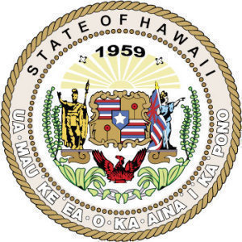  STATE OF HAWAII  DEPARTMENT OF THE ATTORNEY GENERAL  CRIMINAL JUSTICE DIVISION  Law Enforcement Officer Independent Review Board  707 Richards Street, Suite 400  honolulu, hawaii 96813  (808)586-1160  fax (808)586-1375 | CLARE E. CONNORS  ATTORNEY GENERAL  DANA O. VIOLA  FIRST DEPUTY ATTORNEY GENERAL

LAW ENFORCEMENT OFFICER INDEPENDENT REVIEW BOARD
Agenda
Tuesday, January 21, 2020 9:30 a.m.
Leiopapa A Kamehameha, State Office Tower
235 South Beretania Street, Room 203
Honolulu, Hawaii 96813

- Call to Order.

- Discussion on how to apply §28-153(h), Hawaii Revised Statutes (HRS) – the release of the Board’s recommendation upon the adjudication of any criminal prosecution or proceeding.*

- Status of the criminal prosecution involving the death of Justin Waiki and whether the Board’s recommendation regarding this case may be released pursuant to §28-153(h), HRS.*

- Board review of the case involving the death of Renie Cablay.*

- Adjournment.

*To the extent that these matters may involve discussion or review of the Board’s proceedings, recommendations, and records, the Board may go into executive session pursuant to §§ 28-153(g) and 92-5(a)(8), HRS. To the extent that these matters may require consultation with the Board’s attorneys on questions and issues pertaining to the Board’s powers, duties, privileges, immunities, and liabilities, the Board may go into executive session pursuant to §92-5(a)(4), HRS.

All interested persons are invited to attend the public meeting to state their views on the agenda items. Statements may also be mailed to the Department of the Attorney General, 707 Richards Street, Suite 400, Honolulu, Hawaii 96813, or e-mailed to Criminal.Justice@hawaii.gov. Special accommodations for persons with disabilities can be made if requested reasonably in advance by contacting the Department of the Attorney General at the e mail address noted above.

