State of Hawaii
Travel Quarantine Exemption Application User Guide

Getting Started:

Open up a browser and navigate to http://ag.hawaii.gov/travelexemption.

Choose one of the following sign-in methods to create an account:
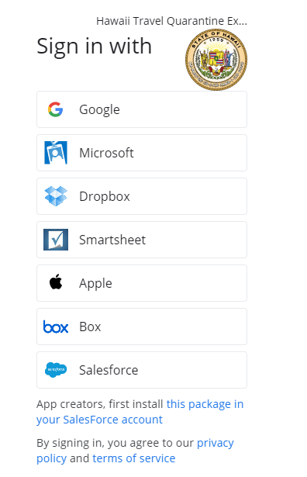

Sign in.
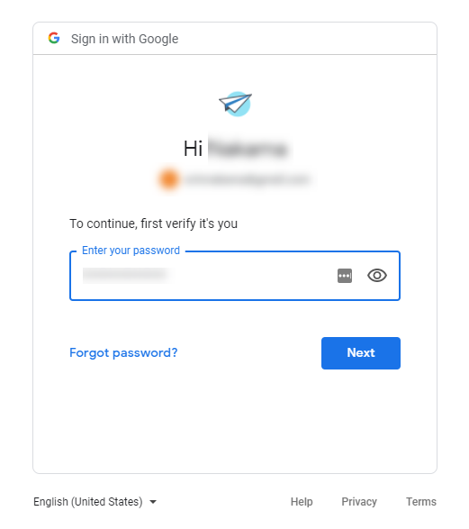

Review the terms and select “Accept” to agree and continue using the app.
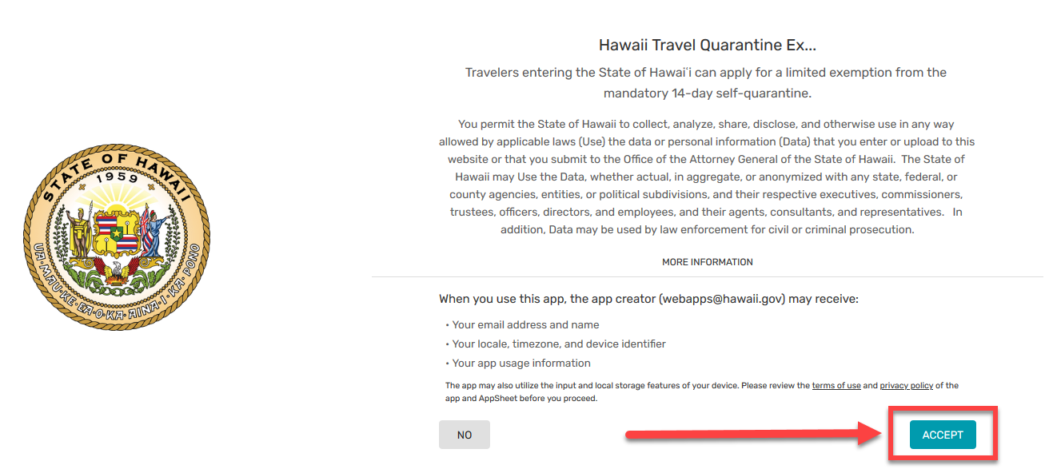

At the bottom of the page select “Complete Your Account.”

Fill out the name and company fields to complete your account and save.
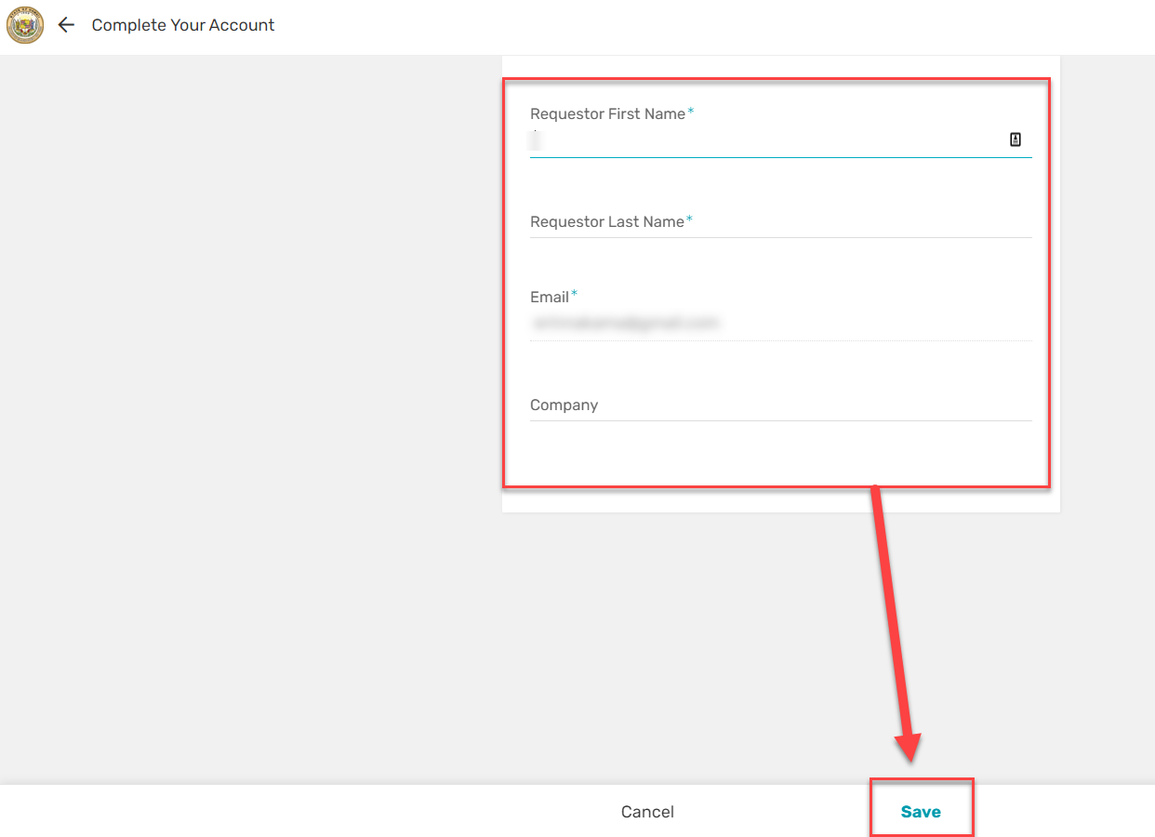

Submitting an Exemption Application Form:

On the bottom right of the application select “Apply for Exemption.”

Select the exemption category that best describes your reason for the request.
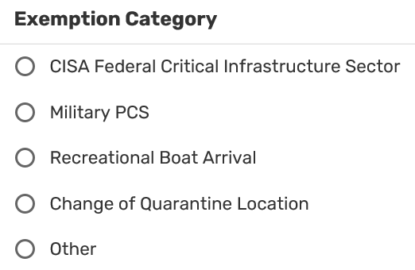

Describe in detail the purpose for your exemption request.
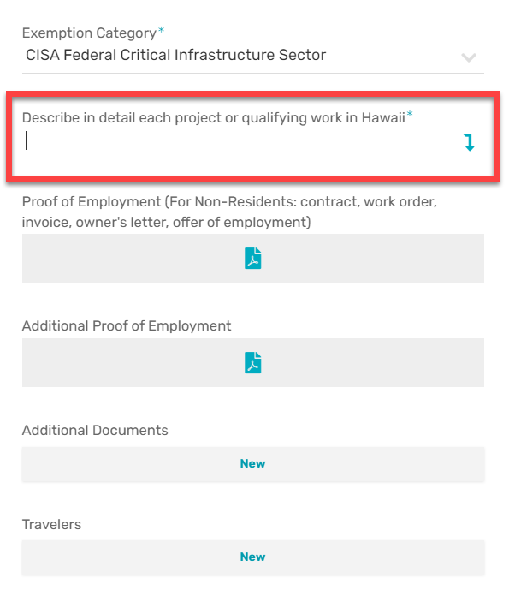

Upload the necessary documents that are requested and any additional documents if needed.
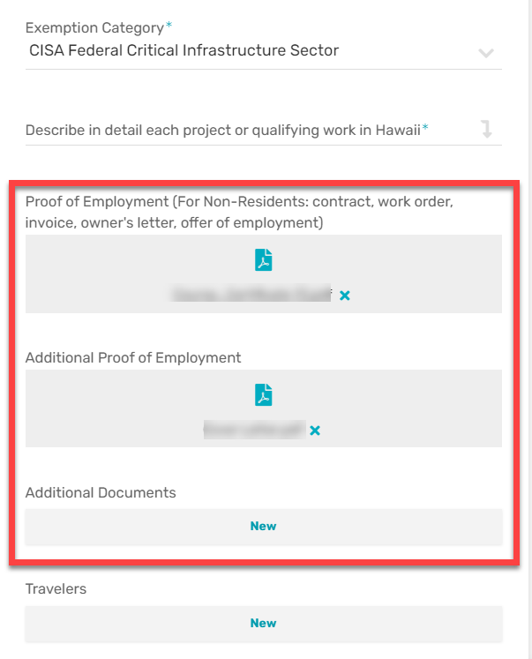

You may add one or more travelers by selecting “New” within the Travelers section on your request. *If you, as the requestor, will be traveling, you will need to fill out one for yourself as well.
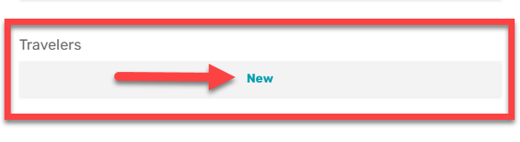

Fill out all the required fields relating to your traveler(s). Each field required will have a “*” next to it. It is important to type in the full address of the traveler’s quarantine location and provide a picture ID. Once completed go ahead and click “Save.”
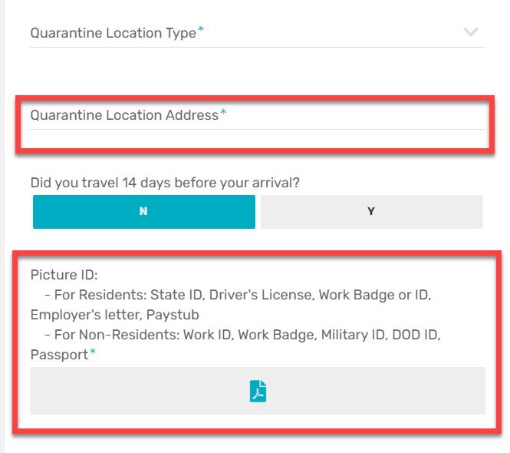

After saving the information for the traveler, you may select the “New” option to add additional travelers if needed. *You will need to provide information for each additional traveler individually*
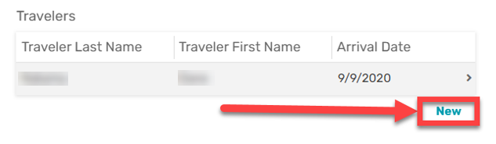

When you have completed filling out your request and traveler information, click “Save”. To finalize and submit your request you will need to select the “Submit” button at the top of the form.
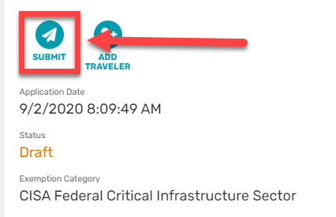

You will be prompted to confirm that the form will be submitted and changes will not be allowed after selecting “Submit.”
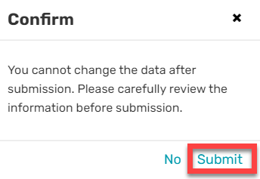

You can verify your submission was successful by referring to the Status on your request.
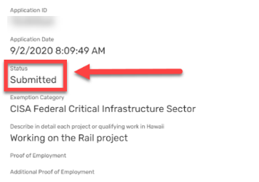

You will receive a confirmation email that includes your Application ID to reference, an assistance contact, and references to county rules. *Your confirmation email does not mean your request has been approved*

Congratulations on completing your first exemption request 😊! To track your submission(s) go to the “Requests” area on the bottom menu.

How to revise a returned request:

If your request requires more information, you will receive an email informing you that an update to your application has been requested, with a link direct to the request within the app. Refer to the email comments to see what updates are being required.
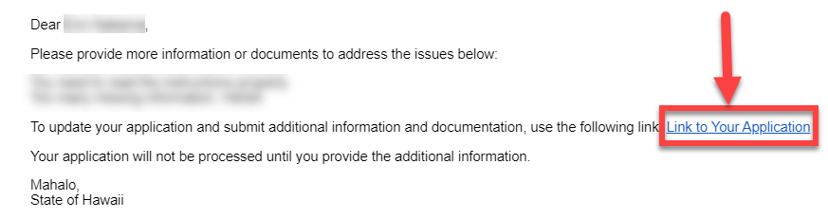

Once logged into the application, under “Requests,” you will see the request that requires an update and it will be shown in red.
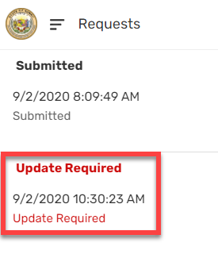

To update your application, open the request and select the icon located in bottom right corner.
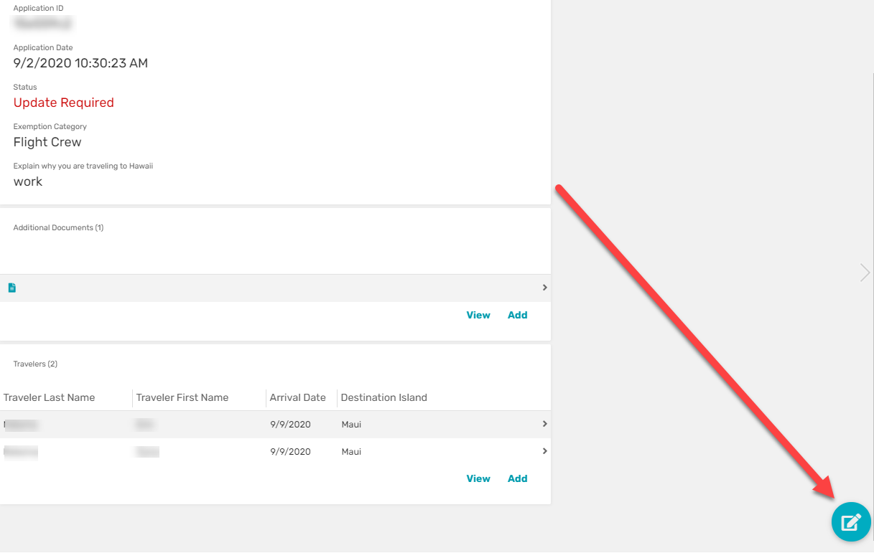

After updating, go ahead and re-submit the request by clicking the “Resubmit” button.
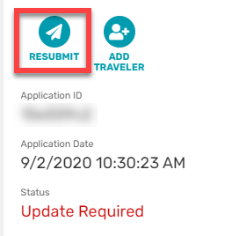

You will receive a confirmation email when your request has been successfully re-submitted. *This does not confirm that your request has been approved. Re-submissions of updates will need to go through evaluation again*

Status notices of submitted requests

Denied ☹: You will receive an email to inform you if your request has been denied with a reference to the Application ID.

Approved 😊: You will receive an email to inform you if your request has been approved including an Approval ID and terms to abide by.

Other Resolution: You will receive an email with a response from the Attorney General’s Office.

You can track the status of your request within the application in the “under “Requests”” area.
